CN Lab 4

Fatima Sohail Shaukat

2020-CE-37

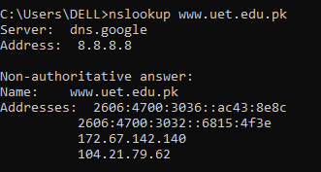Lab task 1:

Q1:

Q2:

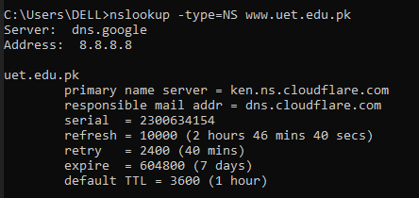

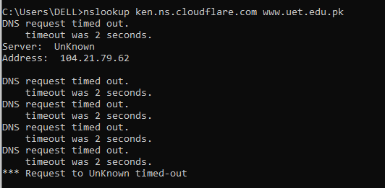Q3:

Lab task 2:

Q1:

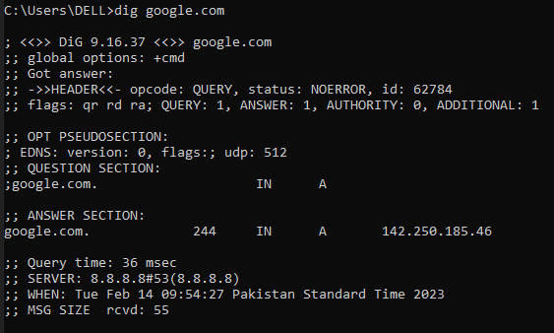

1. IP address = 142.250.185.46
2. The second column represents the TTL (time to live) in seconds.

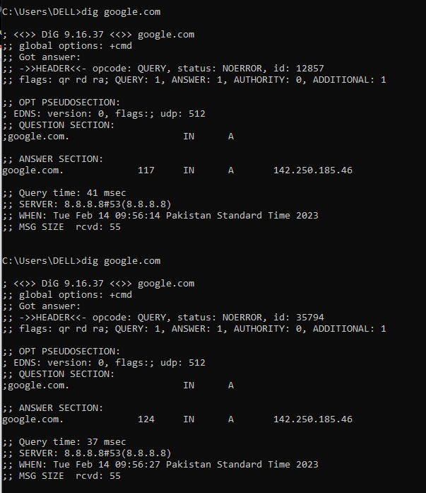

Q2:

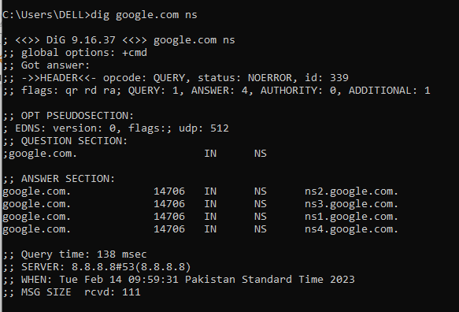

1. There are several ns for the host. An NS record is a DNS record that contains the name of the authoritative name server within a domain or DNS zone.
2. There are four name servers for google.com

Q3:

It provides the Mail Exchange records for google.com. It is a mail server responsible for accepting email messages on behalf of a domain name. It indicates to what specific IP address emails need to be sent.

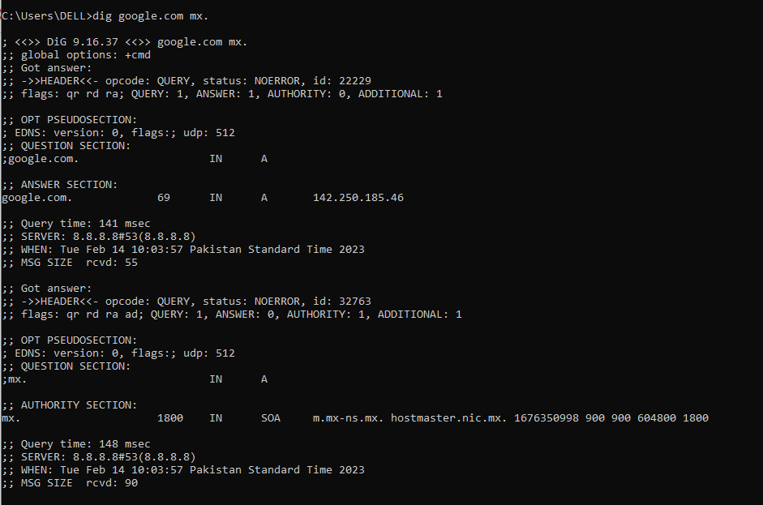

Q4 (a)

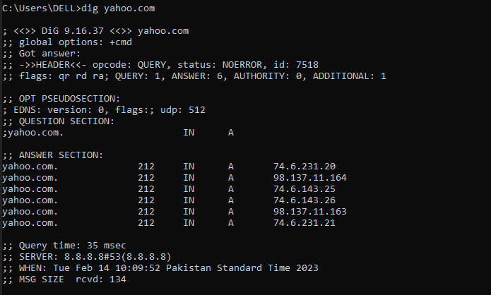

There are six IP addresses associated with yahoo.com

Q4 (b)

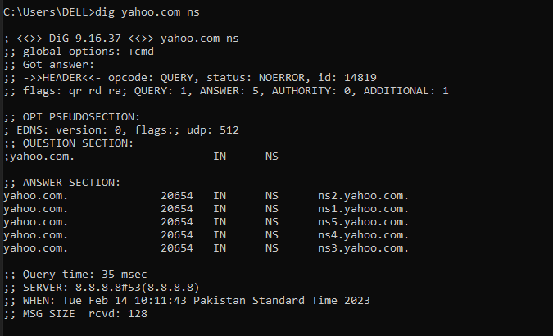

Total five name servers for yahoo.com

Q5:

1. There is only one IP address associated with ww.google.com.

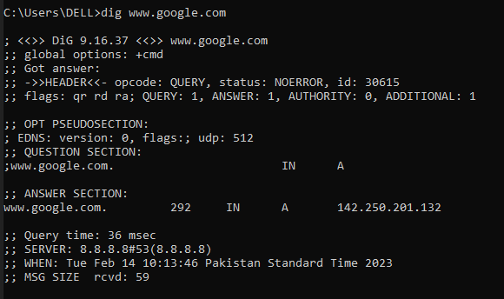

1. Only one name server for [www.google.com](http://www.google.com)

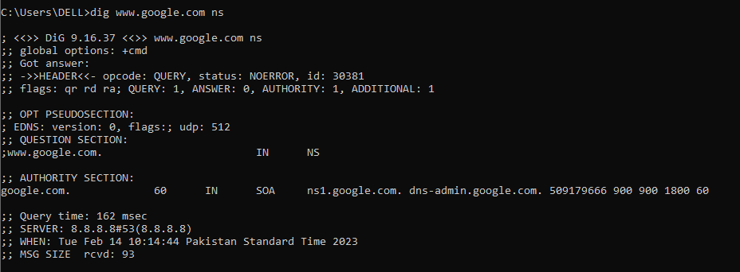

1. The number of IP address for both these commands are same but the number of name servers are different.

Q6:

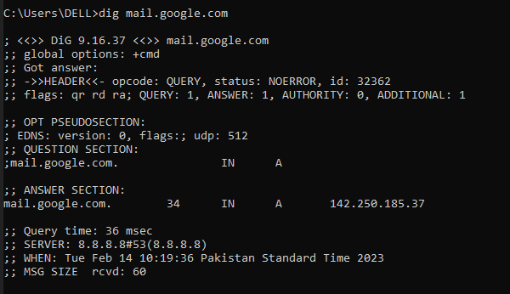

1. Only one IP address is associated with mail.google.com
2. The first three octets of both the servers is same, only the last octet is different for both the servers.

Q7:

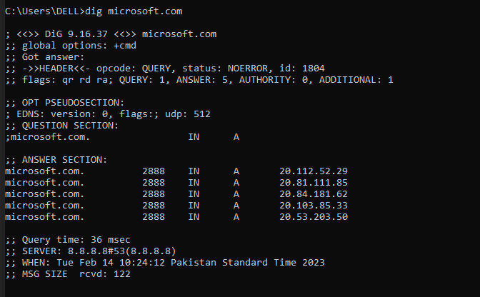

1. The Query time for the first and second run is 36msec.
2. The query time is now 40 msec.

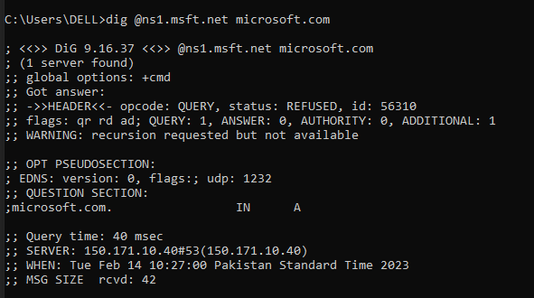

1. The query time is now 35 msec.

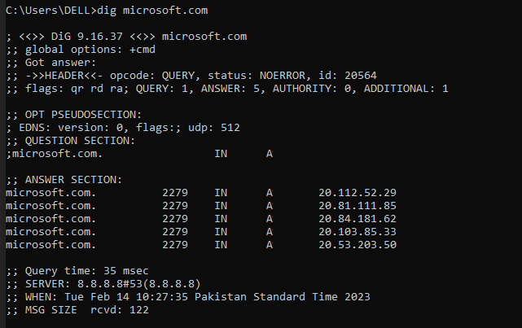

1. After running the dig @ns1.msft.net microsoft.com command, the query time for dig microsoft.com command is reduced by 1 msec.

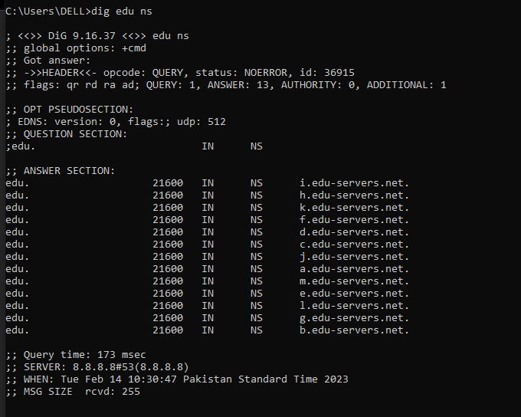Q8: Running the command: “dig edu ns” gives 13 name servers for edu servers.

Q10: Running the command “dig ns” gives 13 name servers for root servers.

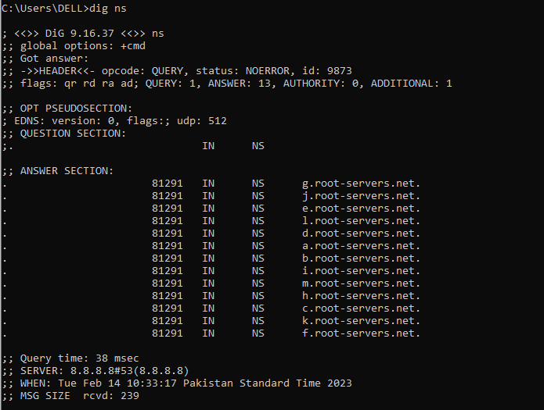

Q 11

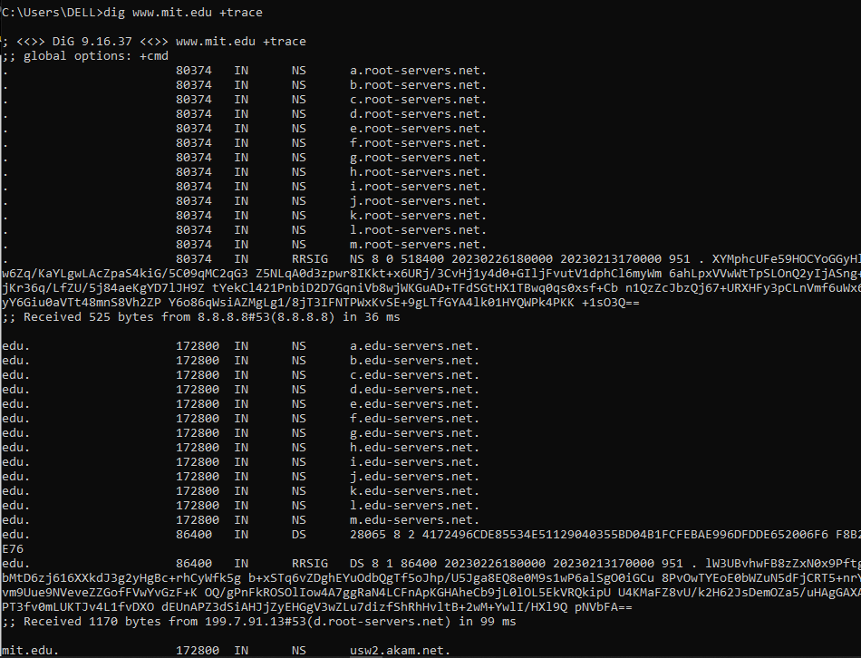

1. Adding the +trace option resolves the query starting from the root nameserver and working its way down, reporting the results from each step. It shows all the root servers, edu servers and AKAM. Let’s check what AKAM is through “whoIs”.

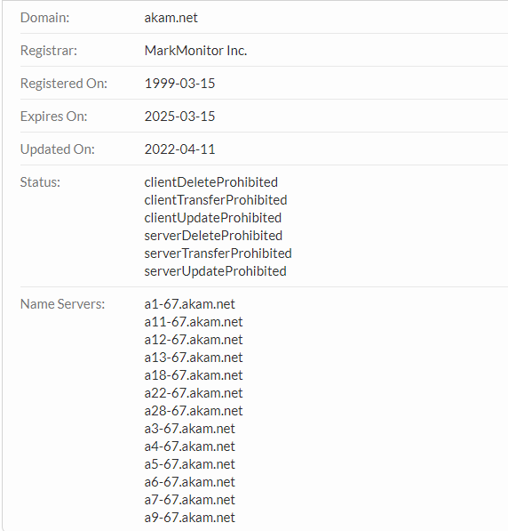

1. Tha followings are the paths:

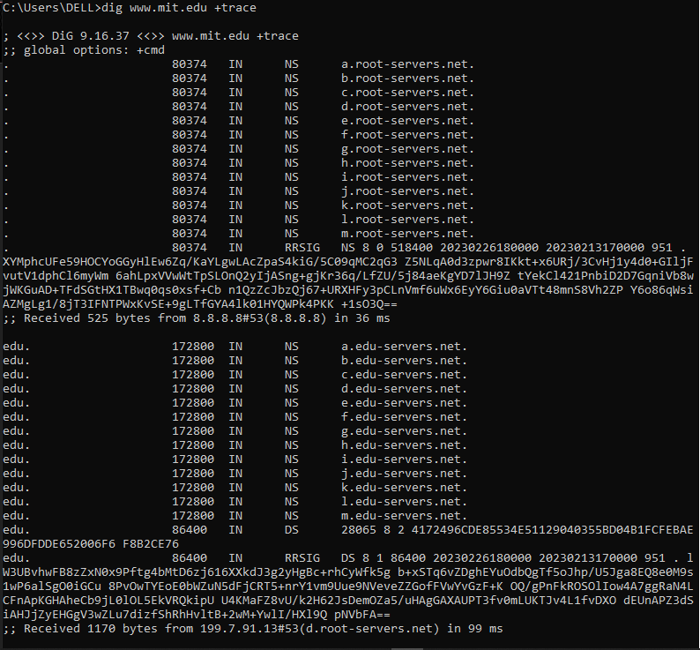 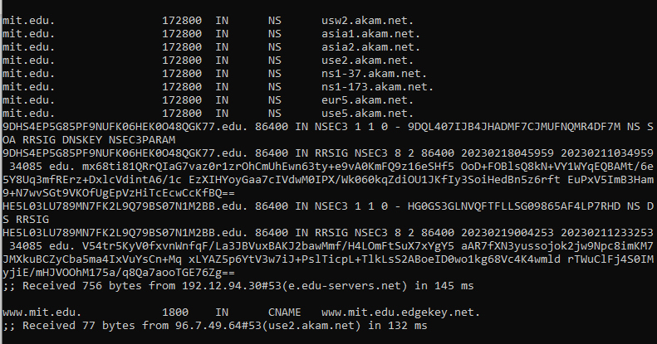

1. The only difference we encounter by running the same command again and again is that the TTL changes. The final TTL for fourth run is 191 ms.